Title + Subhead
The Cloud…Covered!
Lightweight Composite Access Covers Designed For Cloud And Data Centres Speed-Up Access To Underground Infrastructure And Fibreoptic Cabling

Body
The construction challenges of cloud and data centres continue to change and evolve with the ever-increasing use of and reliance on the facilities. Today sees an increasing focus on efficiency, reliability and reduced downtime, while build schedules continue to tighten. Perceived rate of obsolescence also continues to be an important consideration.
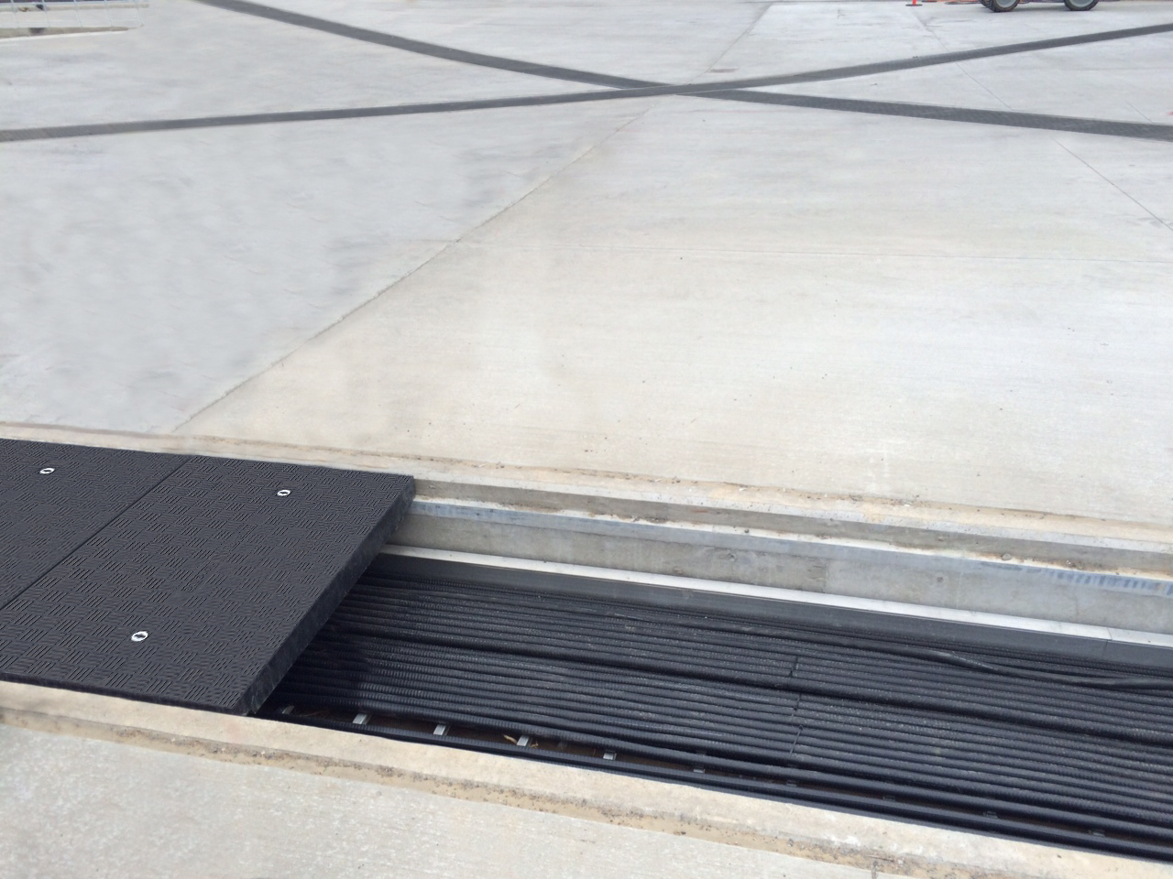
Designers, architects and construction companies are using a variety of methods to tackle these challenges including using modern materials, and agile or modular designs. One of the contemporary products being adopted is the GRP composite channel access covers made by Fibrelite, which offer many unique benefits.

Composite Access Covers Simplify Construction and Maintenance
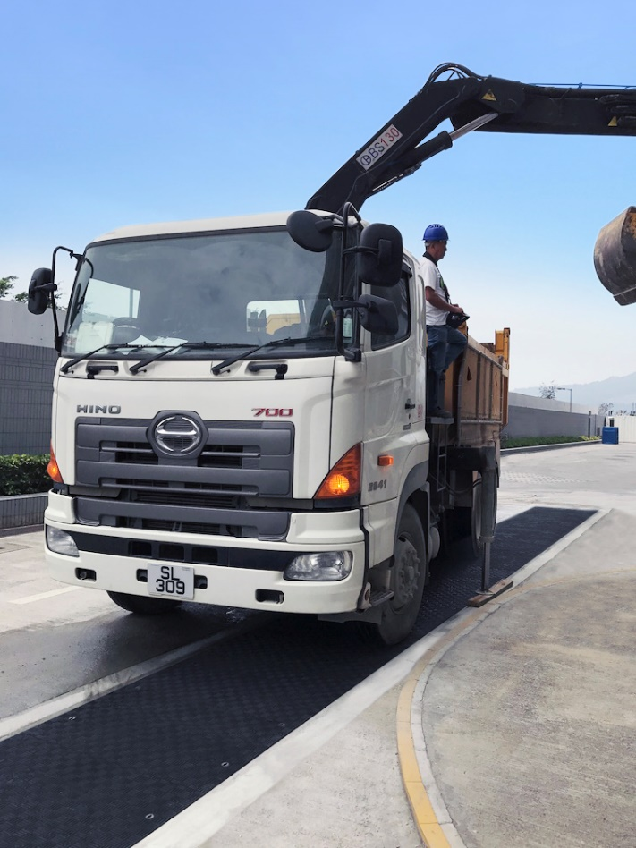
Fibrelite’s bespoke modular GRP composite infrastructure/cable trench access covers are being adopted to increase the efficiency of cloud and data centre construction and maintenance. To date, they have been installed in facilities throughout Europe, Asia and America, and specified by some of the world’s largest brands. For the last 30 years, Fibrelite’s lightweight composite manhole covers have also been specified by many leading oil companies around the globe for use on their petrol stations. Locally, this includes BP, Esso, Total, and many more. In fact, Fibrelite created the world’s first composite manhole cover, back in 1980. If you have a car, you will have walked over a Fibrelite cover many times when refuelling.
The designers and construction companies building today’s cloud and data centres are adopting Fibrelite trench/channel access covers to cover and provide access to channels housing underground infrastructure and fibreoptic cabling. Traditionally, these covers were made from concrete or metal. However, Fibrelite’s innovative modular GRP covers are far lighter and allow safe fast manual removal, even when heavier load ratings are required (e.g. channels running between buildings with vehicle traffic). Fibrelite covers are available in load ratings up to F900/90 tonnes, are impervious to corrosion and have a unique anti-skid walking surface.
Fibrelite covers installed over infrastructure systems and fibre optic cabling at data centre emergency vehicle access point

In many instances where these covers are adopted, companies choose to specify a bespoke option, custom-manufactured to the exact size, colour, load rating and fittings (e.g. securing systems) sometimes as a retrofit replacement for previously installed concrete or metal covers.
“In environments like data centres and cloud facilities where efficiency and flexibility are vital, it’s important to simplify every process possible. We’re impressed at how the level to which data centres are adopting our composite covers for just such a purpose”
Jo Stott
Marketing Director – Fibrelite

For more details on how Fibrelite covers are being adopted, visit their case studies page

ENDS

Notes for Editor:
Full quality images available on OPW’s MyNewsDesk here

About Fibrelite
Fibrelite is a global manufacturer of highly-engineered glass reinforced plastic (GRP) composite access covers that are capable of taking up to 90-tonne loads while still being light enough to be lifted by hand. The company is renowned for its high-quality technical support and service.
Initially developed almost 40 years ago, and now an industry standard for petrol station forecourts, Fibrelite covers are increasingly specified for both new and retrofit work across variety of industries in more than 80 countries. To find out more, please visit www.fibrelite.com
For more information, please contact Aaron McConkey (aaron@fibrelite.com +44 (0) 1756 799773)
Fibrelite; Snaygill Industrial Estate; Keighley Road; Skipton; North Yorkshire BD23 2QR

