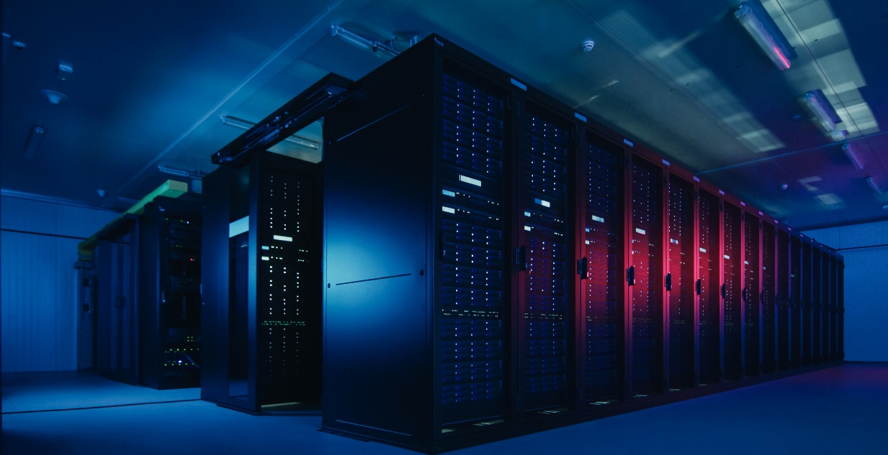
Data Centres Specify KPS High Density Polyethylene
(HDPE) Piping & Fibrelite Composite Access Covers
To Safeguard 24/7 365 Operation

In an increasingly connected digital world, data centres are critical. With 3.6 million m² in use by data centres in Europe alone and over 70 projects (851,000 m²) in progress in 12 European countries (ResearchAndMarkets), their growth continues to accelerate to meet the needs of cloud technology, AI, 5G, Internet of Things (IoT) data storage and the shift to hybrid working. This trend is mirrored globally, with investment in data centres projected to rise from $244.74 billion in 2019 to $432.14 billion in 2025 (ResearchAndMarkets).
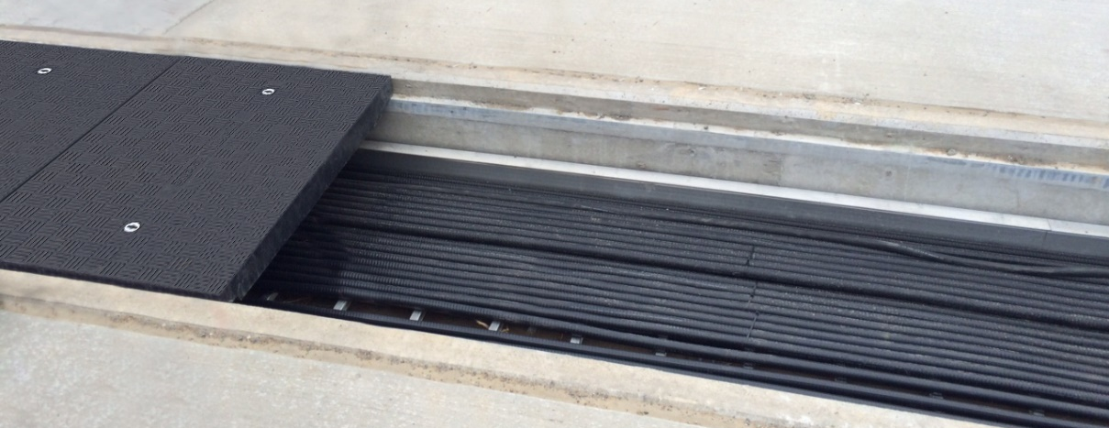
Fibrelite’s FRP composite channel access covers installed at major US data centre
Safeguarding Service. Eliminating Downtime.
To ensure 24/7 365 operation and minimise the risk of downtime, data centres are constructed with the highest performance, highest quality building materials available, with every part of a facility meticulously planned. Infrastructure is an integral part, normally comprising of an Uninterruptible Power Supply (UPS), power distribution, cooling systems, fire systems and security systems, many of which have redundancies (2N+1 for Tier 4 facilities, guaranteeing 99.995% uptime) including back-up power generators to prevent interruption of service. Two contemporary products being adopted by leading data centres across the globe are Fibrelite’s lightweight FRP composite trench access covers (to protect and provide easy access to underground infrastructure) and KPS’ HDPE piping (to fuel backup generators).

High-Performance Backup Generator Fuelling Systems.
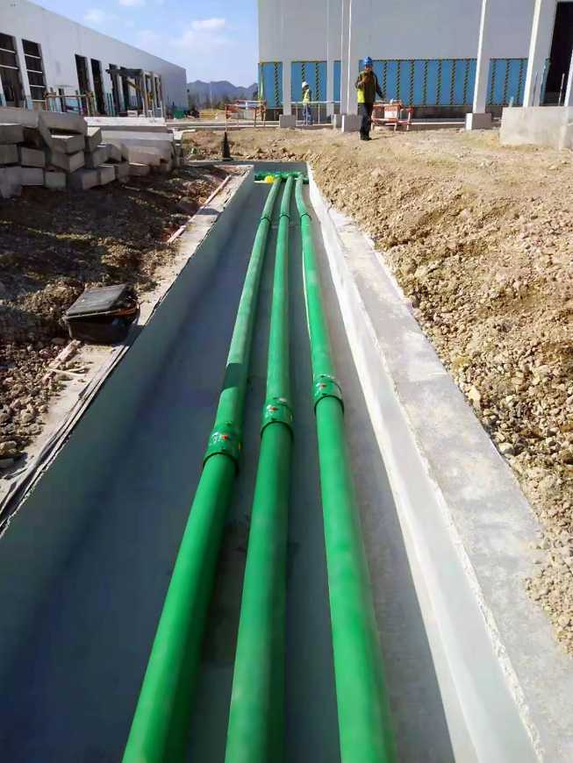
A reliable fuel supply is key to backup generators’ smooth operation, connecting generators to fuel storage tanks and tanks to fill points. Nicolas Lefebvre, Generator Activity Manager at Flipo-Richir (France) commented “We regularly install generators to back up data centres in the event of a power cut. We have been using KPS double wall piping exclusively for more than 10 years to connect generators to underground storage tanks. KPS piping is easy to install, mainly thanks to the assembly by thermo-welding, and the range of products is very complete, which makes it possible to create any type of network, even complex.”
KPS piping installed at Chinese data centre for one of the world’s leading tech brands
Corrosion-resistant, safe and easy to install (due to compact electrofusion fittings) the KPS HDPE piping system helps fuel flow safely, even providing protection against ground movements (using the elasticity and flexibility of HDPE). Safety can be enhanced further by installing KPS’ conductive piping option, ensuring continuous conductivity between the tank and the end of the line (which can be earthed). This helps to prevent the accumulation of electric charges that could otherwise be created by the friction of the fuel velocity and the plastic inner surface. KPS’ 4” (110mm) piping also delivers a 933 litre/minute flow rate, making it ideal for fill lines (KPS piping is available in 1” to 4” diameters in single or double wall). KPS will also soon be releasing a 6” double wall product range.
Simple, Safe Underground Infrastructure Access.
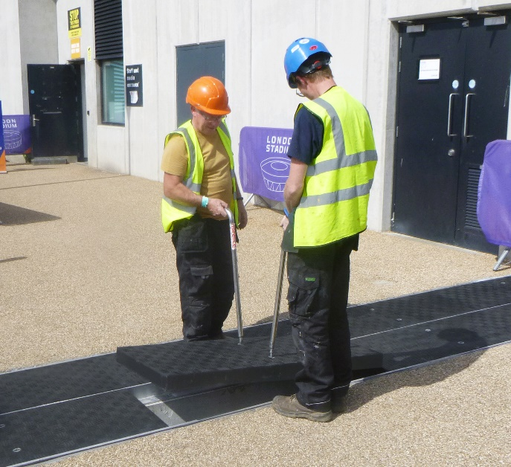
Another contemporary product line seeing widespread global adoption by architects, design engineers and specifiers to enable easy access to underground infrastructure is Fibrelite’s modular FRP composite trench/channel access covers. These are now often specified at the outset of new build data centre projects. Bespoke, modular and lightweight, Fibrelite covers are designed to be removed quickly and easily by two people using Fibrelite’s ergonomically designed lifting handles, even where heavier load ratings are required (e.g. channels running between buildings with vehicle traffic). Due to their unique custom engineering capabilities, Fibrelite can manufacture access covers at all load ratings up to F900 / 90 tonne (A15, B125, D400, E600 and F900). Traditionally, for the past 100 years, access covers have been made from concrete or metal which are 3-4 times the weight of Fibrelite covers, often requiring specialised lifting equipment to remove and replace. Fibrelite covers are also impervious to corrosion and have a unique anti-slip walking surface.
Lightweight Fibrelite FRP channel access covers designed for safe manual removal and replacement
In many instances where Fibrelite access covers are adopted, companies choose to specify a bespoke option, custom-manufactured to specific requirements including size, colour, load rating, fittings (e.g. securing systems) and moulded identification of below ground services. Fibrelite has also undertaken projects where they have designed and manufactured retrofit replacements for previously installed heavy concrete or metal access covers.
“We are proud to be involved in data centre projects across the globe, with our Fibrelite trench access covers facilitating easy safe access to below ground infrastructure, and our KPS piping providing a reliable fuel supply to backup generators. In many cases, we actually custom design and engineer bespoke products to fit each facility’s requirements.”
Jo Stott, Marketing Director, OPW Global (a Dover company and parent company of Fibrelite and KPS)

Explore KPS’ technical case studies here: www.KPSpiping.com/datacentres
Explore Fibrelite’s technical case studies here: www.fibrelite.com/datacentres

Notes for Editor:
Full quality images available on OPW’s MyNewsDesk here

About KPS
The KPS plastic piping system has been making fluids flow safely for over 40 years below forecourts across the globe. Manufactured from HDPE, KPS piping is designed for fast, simple installation, providing a tried and tested long-term fluid transfer solution that’s liquid/watertight and corrosion-free. KPS also pioneered conductive HDPE piping, providing an electrostatically safe plastic solution to replace metal piping.
Suitable for petrol, diesel, Jet-A1, Ethanol blends and other alcohols (conductive), and chemicals, the KPS piping system is engineered for installers, with highly engineered compact electrofusion fittings. In fact, KPS’ double wall fittings are the only ones on the market which weld both pipe walls simultaneously. KPS also prides themselves on their installer training programme and certification, offering classroom and on-site training to familiarise installers with KPS piping and electrofusion welding system.
Since 2013, KPS has been a part of OPW (a Dover company) allowing them to offer an unprecedented portfolio of complementary best-in-class products.
For more information, visit the KPS website at www.kpspiping.com
About Fibrelite
Fibrelite is a global manufacturer of highly engineered Fibre Reinforced Plastic (FRP) composite manhole and trench access covers capable of taking up to 90-tonne loads while still being light enough to be removed manually by one or two people using Fibrelite’s ergonomically designed lifting handles. In 1980, Fibrelite designed the world’s first composite manhole cover for Esso UK (ExxonMobil), eliminating manual handling and other health and safety issues associated with traditional metal covers. Today, Fibrelite continue pioneering composite technology, continually innovating to solve customers’ challenges across the globe.
Initially developed over 40 years ago, Fibrelite remains the composite access cover of choice for projects the world over, from data centres and high-tech manufacturing facilities to infrastructure, transport and stadia, and is the industry standard for petrol station forecourts. Fibrelite covers are increasingly specified for both new build and retrofit projects across a variety of industries in more than 80 countries.
For more information, visit the Fibrelite website at www.fibrelite.com

For more information, please contact Jo Stott, Marketing Director (jo.stott@opwglobal.com +44 (0) 7807 765 140)

https://www.prnewswire.com/news-releases/europe-data-centre-market-report-2021-2025-a-46-growth-in-european-data-centre-revenues-and-a-53-growth-in-public-cloud-revenues-301227565.html
https://www.prnewswire.com/news-releases/global-data-center-market-report-2021-growth-opportunities-in-edge-computing-investmentma-new-capabilities-geographic-expansion-partnerships-artificial-intelligence-liquid-cooling-renewables-301231802.html

