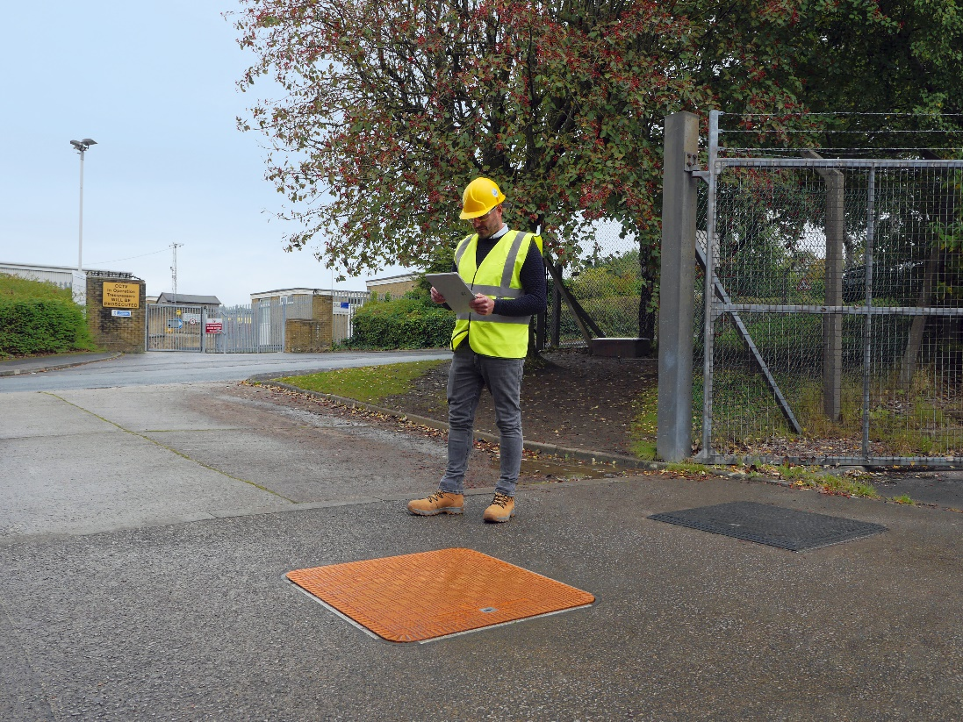
Announcing Fibrelite’s New Generation Of Radio Frequency Friendly Manhole Covers – Designed For Remote Underground Monitoring
Fibrelite’s new Radio Frequency friendly manhole cover
Fibrelite’s New Generation Cover
Following increasing demand for Radio Frequency (RF) friendly manhole covers, composites manufacturer Fibrelite has developed a new range of manhole access covers, designed to support data transfer between antennas underground and aboveground.
One of the primary current uses of RF/smart manhole covers is as part of (real-time) remote underground monitoring systems/telematics in utilities, where transmitters under covers are used for monitoring and/or control of oil/water usage, sewer flow, floodwater and similar. Other industries adopting these include mining and telecoms (e.g. 5G signal boosters).

The Technology Explained
Traditional ductile iron and reinforced concrete manhole covers aren’t conducive to the transmission of RF signals. Metal reflects the signal, while concrete greatly weakens it (exhibits high attenuation coefficients). This means that the transmitted signal is greatly weakened, restricting range and functionality. Glass Reinforced Plastic (GRP) in contrast, absorbs far less of the signal (lower attenuation coefficient). Full details in whitepaper.

Recent Installations: From Cadiz To Connecticut
Over a five-year period, Fibrelite’s standard GRP covers have been installed by the municipality of Cadiz in Spain (case study) for their drinking water monitoring system (initially cast-iron covers had been installed over the system, but the signal was being blocked).
Over 100 bespoke radio frequency manhole covers (designed to fit the Sensus flow meter antenna) have been installed in Connecticut (case study) as part of an effort to automate their water meter collection services (automated water meters installed below the covers) following a successful 6-month trial.

Tried And Tested
Fibrelite’s new Radio Frequency manhole cover, the FL60RF draws on the low attenuation (signal absorption) properties of GRP and includes a thin structure in the middle of the cover to contain the antenna; further lowering the attenuation of the signal without compromising the strength or deflection properties of the cover.
Tested at university of Lancaster on behalf of Fibrelite, the new FL60RF showed far lower attenuation compared to a 2mm thick aluminium plate (see image) and passed the load bearing test EN 124 C250 (now certified to C250 (25 tonne) load rating). Full details in whitepaper.
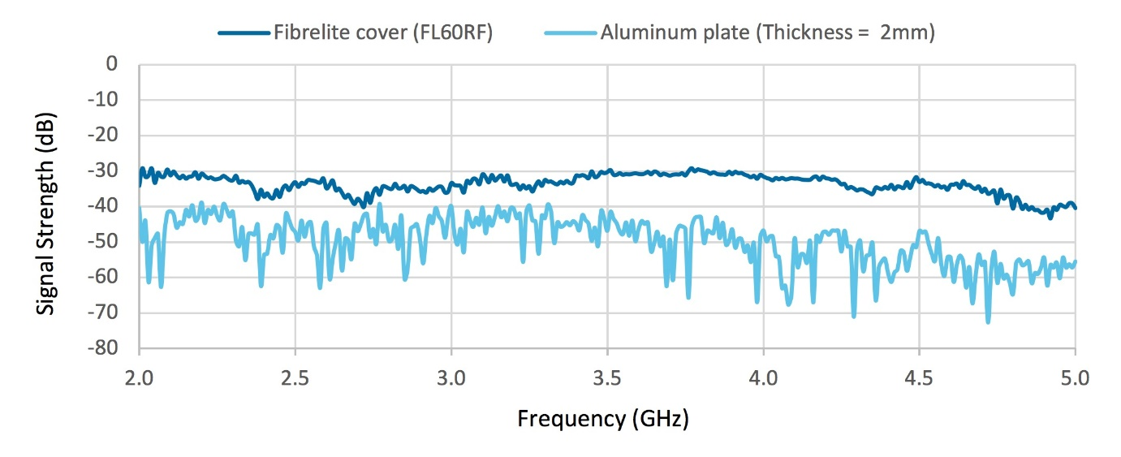
Fibrelite FL60RF attenuation compared to a 2mm thick aluminium plate

ENDS
Notes for Editor:
Full quality images can be found on our MyNewsdesk Service
About Fibrelite
Fibrelite is a global manufacturer of highly-engineered glass reinforced plastic (GRP) composite access covers capable of taking up to 90-tonne loads whilst still being light enough to be lifted by hand and is renowned for its high-quality technical support and service.
Initially developed almost 40 years ago and now industry standard for petrol station forecourts, Fibrelite covers are increasingly specified for both new and retrofit work in a variety of industries in more than 80 countries around the world. To find out more, please visit Fibrelite’s website

For more information, please contact Aaron McConkey (aaron@fibrelite.com +44 (0) 1756 799773)
Fibrelite; Snaygill Industrial Estate; Keighley Road; Skipton; North Yorkshire BD23 2QR

