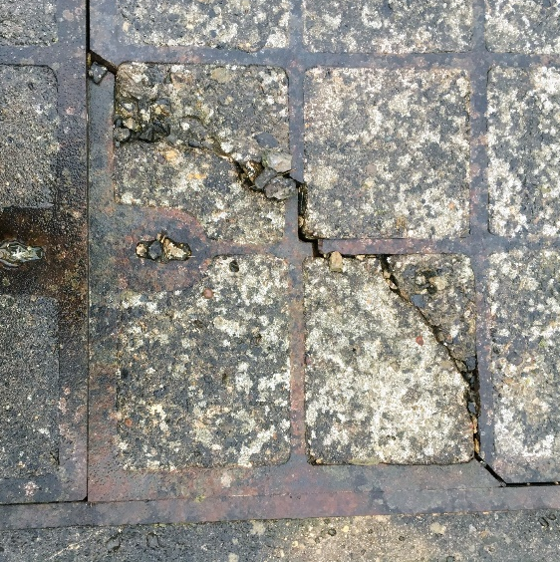
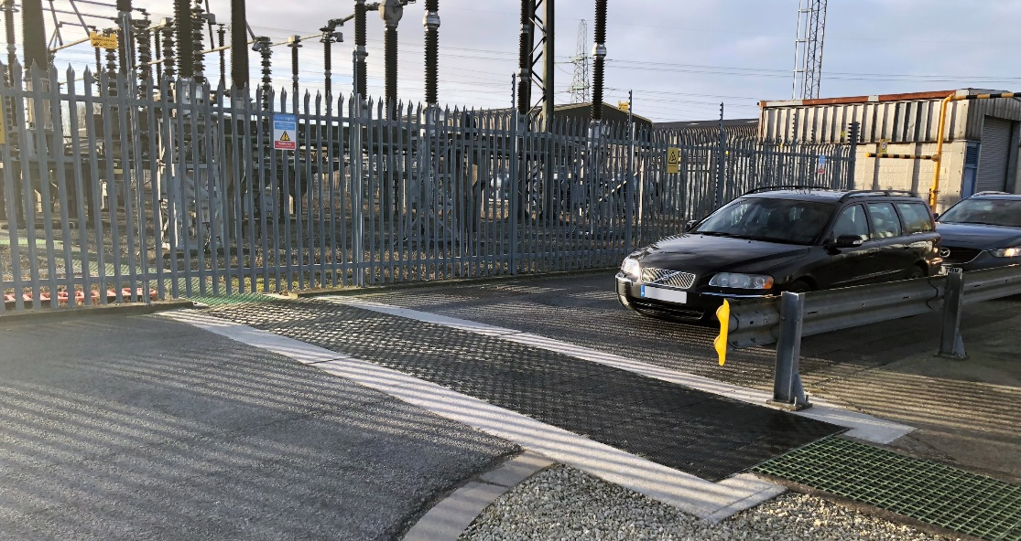
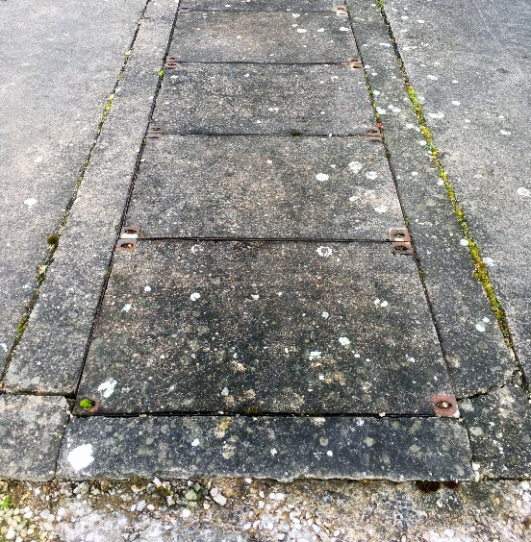
UK Power Generation Facilities Adopt
Made-to-Measure Composite Trench Covers
Bespoke D400 Fibrelite composite covers installed at UK power station (top) to replace failing concrete covers (below)
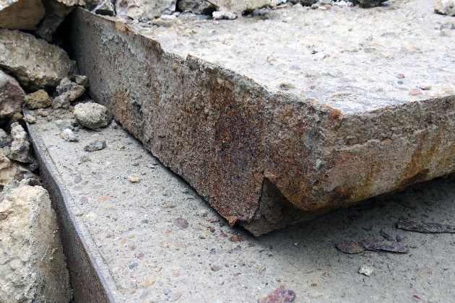
Electrical power generation facilities have large quantities of cabling running below the ground as a matter of course, which must be accessed regularly. Back in the 1960s when many of these facilities were built, heavy concrete and steel or cast-iron trench access covers were the only option available. While there were associated risks and often specialised equipment required to remove and replace them, they served their purpose.
Today, many sites are discovering deterioration of the structural integrity of their steel and concrete trench covers, exacerbating manual handling risks, and, where located on road crossings, potentially restricting vehicular access to certain areas of the site.
Deterioration of concrete cover on UK power station

GRP Composites: A Safe, Long-Term Solution
Many sites are subsequently upgrading to made-to-measure heavy-duty lightweight Fibrelite GRP composite trench covers, especially on road crossings where both a high load rating (often D400 40 tonne) and frequent access is required.
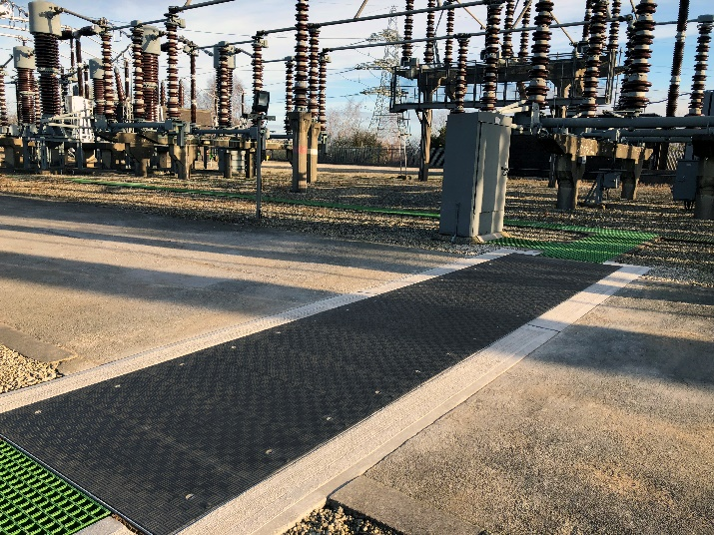
With an unrivalled strength to weight ratio, Fibrelite’s highly engineered GRP composite material is significantly lighter than metal, yet just as strong, and is fast becoming recognised as an effective modern alternative to traditional steel and concrete. In fact, due to the lightweight properties of their composite material, Fibrelite GRP covers are approximately one third of the weight, and all can be safely manually removed by one or two people with their ergonomically designed lifting handles. Fibrelite’s highly engineered composite covers also have an inherent resistance to corrosion, requiring a minimum of maintenance while providing a long-term solution.
Fibrelite GRP composite covers (pictured) are approximately 1/3 the weight of traditional materials

Fibrelite: Over 30 Years of Composite Expertise
Fibrelite, the global leader in the manufacture and development of GRP manhole and trench covers draws their expertise from over 30 years of working with and being specified by the majority of the world’s leading oil companies including locally BP, Esso, Total, and many more. Look down on any petrol station forecourt, and odds are, you’ll see one of their covers. They actually invented the world’s first composite access cover back in 1980 for Esso UK (ExxonMobil) to solve manual handling injuries; and their covers are now specified in myriad industries globally.
Fibrelite is proud to design and manufacture in the UK for the UK, enabling a rapid design to delivery process.
Since 2013, Fibrelite has been a part of OPW (a Dover company) allowing the company to offer an unprecedented portfolio of complementary best-in-class products.
For more details on how and where Fibrelite covers are being adopted, visit their case studies page

ENDS
Notes for Editor:
Full quality images available at https://we.tl/t-oLi40PmlyO
About Fibrelite
Fibrelite is a global manufacturer of highly-engineered glass reinforced plastic (GRP) composite access covers capable of taking up to 90-tonne loads whilst still being light enough to be lifted by hand and is renowned for its high-quality technical support and service.
Initially developed almost 40 years ago and now industry standard for petrol station forecourts, Fibrelite covers are increasingly specified for both new and retrofit work in a variety of industries in more than 80 countries around the world. To find out more, please visit Fibrelite’s website

For more information, please contact Aaron McConkey (aaron@fibrelite.com +44 (0) 1756 799773)
Fibrelite; Snaygill Industrial Estate; Keighley Road; Skipton; North Yorkshire BD23 2QR

