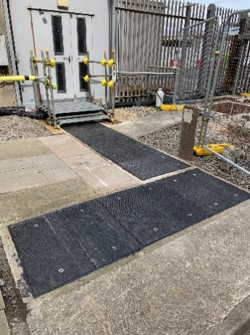
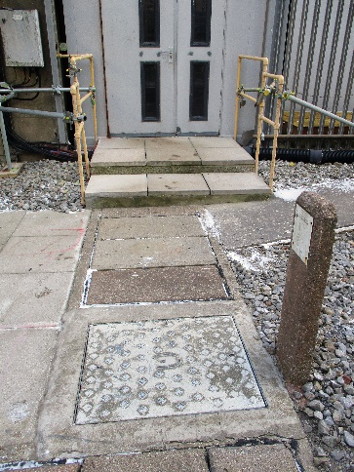
One Of The UK’s Largest Nuclear Decommissioning Projects Specifies Fibrelite Composite Access Covers To Improve Safety And Efficiency

As nuclear decommissioning authorities seek to increase project efficiency while maintaining the highest possible standards of safety, companies responsible for the clean-up of sites look to new products and processes.
Existing Access Cover Challenges & A Bespoke Composite Solution
Magnox Ltd, the company responsible for the decommissioning of 12 nuclear sites in the UK, recently approached composite access cover manufacturer Fibrelite for a solution to access challenges at Hinkley Point A.
Magnox had established that the existing concrete and cast-iron trench and manhole access covering arrangements would be very troublesome long term and had experienced a number of failures across different locations/sites, causing confidence in these covers to be questioned. Key concerns included high levels of corrosion, structural degradation and extreme weight.
Predominantly located in pedestrian and vehicular traffic areas, this lack of confidence had led to large areas being barriered off and exclusion zones put into place.
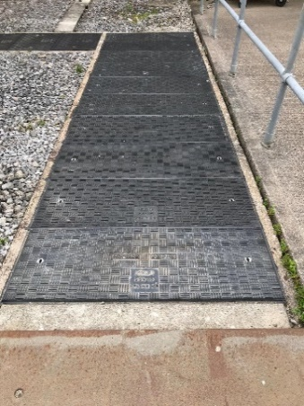
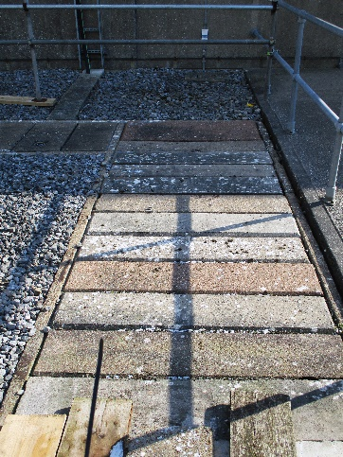
Following discussions with Fibrelite’s technical team Magnox specified Fibrelite covers for a replacement programme at Hinkley Point A.
Previously installed concrete trench access covers had begun to corrode
Fibrelite covers are chemically inert and have an anti-slip tread pattern
The Fibrelite technical team engineered numerous bespoke retrofit GRP composite trench and manhole covers, providing direct replacements for existing covers including differing depths, load ratings, and covers with locking mechanisms (in some instances).

Composite Access Covers Solve Manual Handling & Durability Difficulties
Fibrelite covers proved the ideal solution for Magnox’s requirements, solving the 3 key difficulties experienced with the existing concrete and cast-iron covers trench and manhole access covering arrangements:
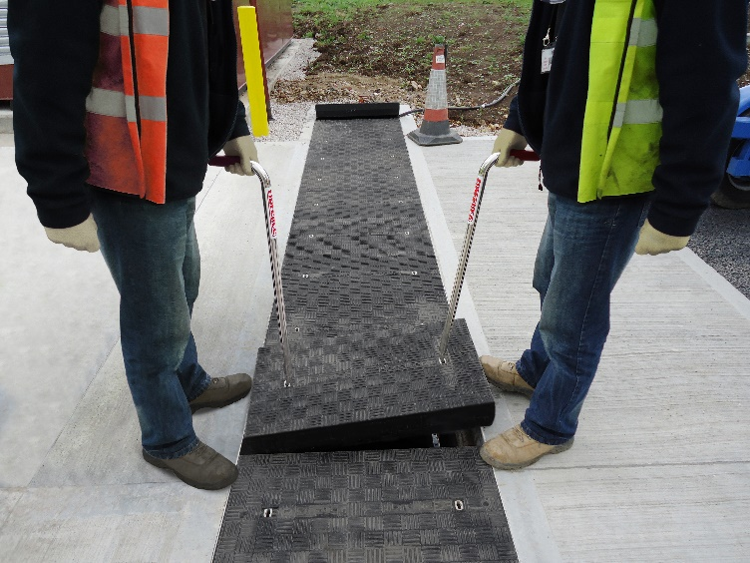
- Weight: particularly in the nuclear industry, ease of access for services is imperative. Heavy concrete access covers impair this. Fibrelite covers are typically 1/3 the weight of similar metal and concrete alternatives and are suitable for a two-person lift.
- Manual handling: Magnox was concerned about the risk of injury due to manual handling of the heavy concrete and metal covers. These concerns were remedied with Fibrelite’s lightweight covers and FL7 ergonomic lifting handles (which allow safe lifting from waist height).
All Fibrelite trench covers can be safely and quickly removed by two people using the FL7 lifting handles (image used for illustration purposes and shows a different installation)
- Deteriorating performance: existing covers were exhibiting high levels of corrosion and structural degradation leading to concerns of fitness for purpose. The new Fibrelite covers are chemically inert so will last for years to come without degradation.
The works was co-ordinated and delivered within a tight schedule to provide a safe, efficient and consistent solution within the decommissioning work being undertaken at Hinkley
Point A.

Fibrelite Covers Specified For Future Magnox Projects
Magnox was pleased with the outcome of the project and advised that they would continue to specify Fibrelite access covers for future projects.
“We’re proud to see our covers increasingly specified in large-scale projects like this and other highly demanding environments, including defence, transportation, stadia, data centres and many more.”
David Holmes, Technical Director, Fibrelite
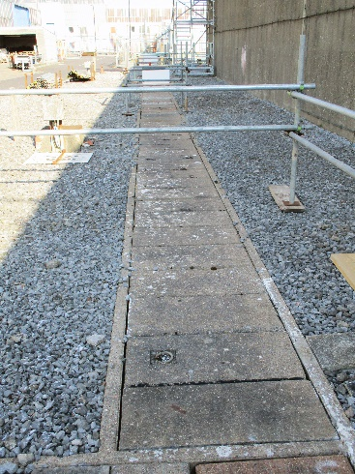
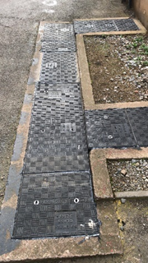
For more details on how Fibrelite covers are being adopted, visit their case studies page
Exclusion zones were put in place to prevent loading causing a failure of existing covers during the decommissioning work
The nuclear facility now has a safe covering for their utilities during the decommissioning work

ENDS

Notes for Editor:
Full quality images available on OPW’s MyNewsDesk here
About Fibrelite
Fibrelite is a global manufacturer of highly-engineered glass reinforced plastic (GRP) composite access covers capable of taking up to 90-tonne loads while still being light enough to be lifted by hand. The company is renowned for its high-quality technical support and service.
Initially developed 40 years ago, and now an industry standard for petrol station forecourts, Fibrelite covers are increasingly specified for both new and retrofit work across a variety of industries in more than 80 countries. To find out more, please visit www.fibrelite.com

About Hinkley Point A
Hinkley Point A, is one of 3 Hinkley Point nuclear power plants located on the Somerset coast, and operated for 35 years before closing in 2000, generating a total of 103 terawatt hours.
For more information, contact Aaron McConkey (aaron@fibrelite.com +44 (0) 1756 799773)
Fibrelite; Snaygill Industrial Estate; Keighley Road; Skipton; North Yorkshire BD23 2QR

https://www.world-nuclear.org/information-library/country-profiles/countries-t-z/united-kingdom.aspx
https://www.gov.uk/government/organisations/magnox-ltd
https://magnoxsocioeconomic.com/ssg.php?site=hinkley-point-a

