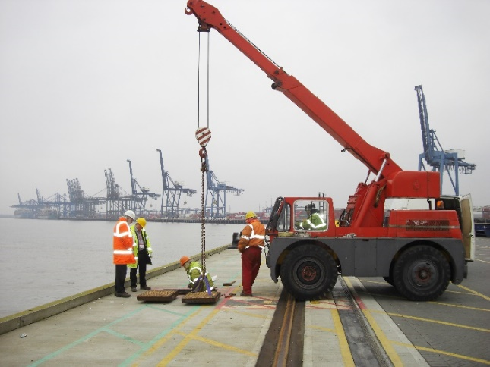
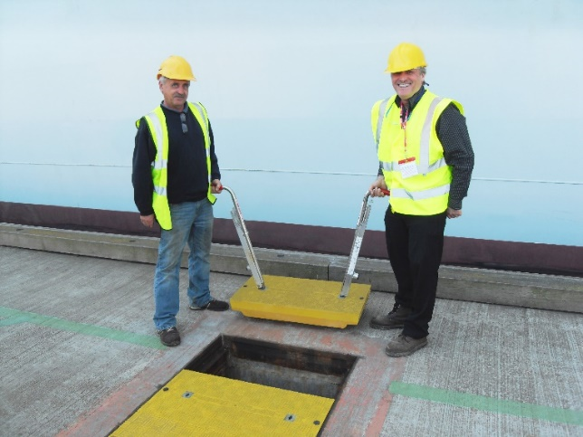
Load Bearing Access Covers Are Going Lightweight
Port of Felixstowe, UK, before and after installing composite trench covers
Conventional load-bearing access and manhole covers are heavy, liable to corrosion and difficult to install and remove. The question facing modern architects and developers is how to retain the accessibility and strength, but improve upon the practicality, durability and performance.

From access covers and manhole covers, to trench covers, steel and concrete have traditionally been the market’s materials of choice. However, these options are often cumbersome to lift and easily corrode – requiring regular maintenance.

To meet the challenges of modern construction, Fibrelite, the global leader in the manufacture and development of GRP composite manhole and trench covers, has developed an ultra-light, yet ultra-strong solution that can be manufactured to match almost any specification, size, colour, or project.
With an unrivalled strength to weight ratio, this highly engineered GRP composite material is significantly lighter than metal, yet just as strong, and is fast becoming recognised as an effective modern alternative to traditional steel and concrete.

This breakthrough has subsequently led to the development of the world’s first F900 rated (90-tonne) load rated composite covers at the Port of Felixstowe - one of the UK’s leading commercial ports.

Designed to protect the fresh water pipes used to supply arriving vessels, the original covers had to be removed and replaced with a mobile crane each time access was required. However, despite sharing the same load rating, the new Fibrelite composite covers can be safely and conveniently installed and removed by a two-man team.

What’s more, unlike conventional steel alternatives, the new replacements are resistant to corrosion from sea salt – making them ultra-durable and maintenance-free. Designed, manufactured and developed specifically for Felixstowe, these covers are colour-coded to denote fresh drinking water and have been engineered to fit seamlessly into the existing frames with custom-made security bolts – providing a made-to-measure fit.
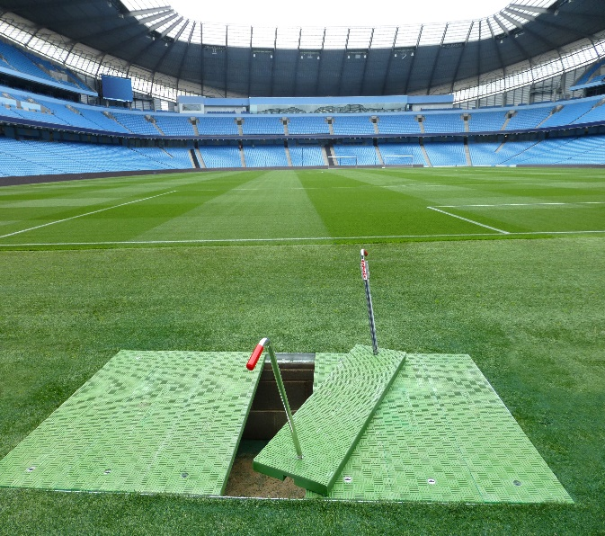
From the Premier League to La Liga, architects and developers in the field of sports stadium design have also been quick to embrace the benefits of GRP composite technology. In areas of high use, such as underground service trenches, high load bearing GRP access covers that can be easily removed and reinstalled are replacing the traditional alternatives.
Fibrelite covers installed in Premier League stadium

Having worked with leading clubs across the world, Fibrelite are experts in creating custom designs to match any application and regularly design maintenance-free, trench covers featuring club colours and logos, to blend into the surrounding pitch. These bespoke designs neatly fit existing trenches and are skid-resistant, making them ideal for pedestrian areas.

Specified by major oil companies worldwide since the 1980s, including locally: ExxonMobil, Total, ADNOC, Woqod, ENOC and OiLibya; Fibrelite’s high performance composite covers can be custom designed to suit any specification in Fibrelite’s dedicated facilities in the UK, the US and South East Asia. A rapid design to delivery process, and a responsive local distribution network also guarantee fast turnaround times.

Since 2013, Fibrelite has been a part of OPW (a Dover company) allowing the company to offer an unprecedented portfolio of complementary best-in-class products.

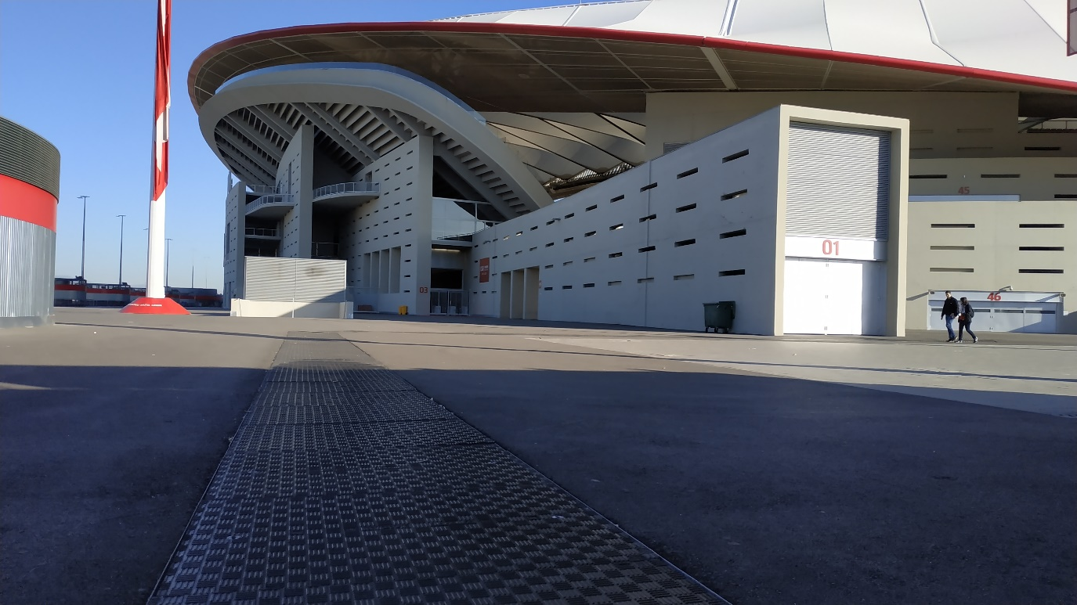
To find out how Fibrelite’s composite trench and manhole covers are being adopted around the globe, check out their case studies here
Fibrelite covers installed in around La Liga stadium
ENDS

Notes for Editor:
Full quality images attached

About Fibrelite
Fibrelite is a global manufacturer of highly-engineered glass reinforced plastic (GRP) composite access covers capable of taking up to 90-tonne loads whilst still being light enough to be lifted by hand and is renowned for its high-quality technical support and service.
Initially developed almost 40 years ago and now industry standard for petrol station forecourts, Fibrelite covers are increasingly specified for both new and retrofit work in a variety of industries in more than 80 countries around the world. To find out more, please visit www.fibrelite.com
For more information, please contact Jo Stott (jostott@fibrelite.com +44 (0) 1756 799773)
Fibrelite; Snaygill Industrial Estate; Keighley Road; Skipton; North Yorkshire BD23 2QR

